|  |
| --- |
| Close-up image showing the leaf-sides of two oversized books side-by-side on a bookshelf, with additional books in soft focus background |
| Installation Guide  **Brightcove Custom Cartridge for Salesforce Commerce Cloud** |
| |  |  | | --- | --- | |  |  | |

Contents

Overview 3

Component Overview 4

Functional Overview 4

Compatibility 4

Limitations, Constraints 4

Steps for Installation 5

Install Custom Cartridge in Business Manager: 6

Setups in SFCC Business Manager: 9

Configure Custom Cartridge via Custom site preferences: 14

# Overview

This document provides technical instructions for installing Brightcove custom cartridge, as well as setting up SFCC Business Manager, for integrating Brightcove Cloud video and media files with Salesforce Commerce Cloud (SFCC).

# Component Overview

## Functional Overview

This custom cartridge is developed based on specifications provided by Brightcove. It enables Salesforce Commerce Cloud business users, to upload videos files to the Brightcove Cloud server through SFCC Business Manager, and publish these files on the product details page

## Compatibility

The custom cartridge is designed for Salesforce Commerce Cloud API with controllers for extended functionality. Custom cartridges are available for SFRA as well as for the Site Genesis architecture. Clients should install version matching with their Salesforce Commerce Cloud architecture.

## Limitations, Constraints

As mentioned above, Brightcove SFCC custom Cartridge is designed to meet Brightcove’s specific requirements to integrate video files residing on Brightcove cloud server with SFCC. To make use of this cartridge, one must contact Brightcove and signup for these services.

# Steps for Installation

* Install custom cartridge in your SFCC Instance Using Business Manager
* Set up SFCC Business Manager
* Configure cartridge via site preferences.

**Note**: To execute steps as mentioned below, access to SFCC Business manager and Brightcove studio is required.

## Install Custom Cartridge in Business Manager:

1. Open Eclipse Studio
2. Import Brightcove cartridges as provided
3. Select on the **Import** box

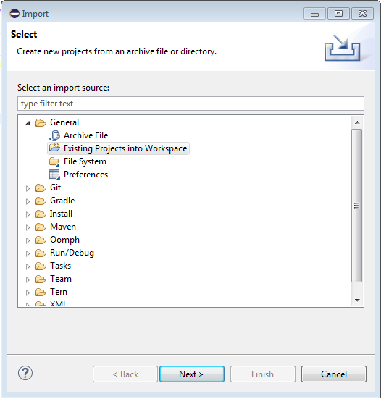

Note: Browse the Local root Directory to the Specific Folder where cartridge library files are located. Select the Cartridges which you want to upload.

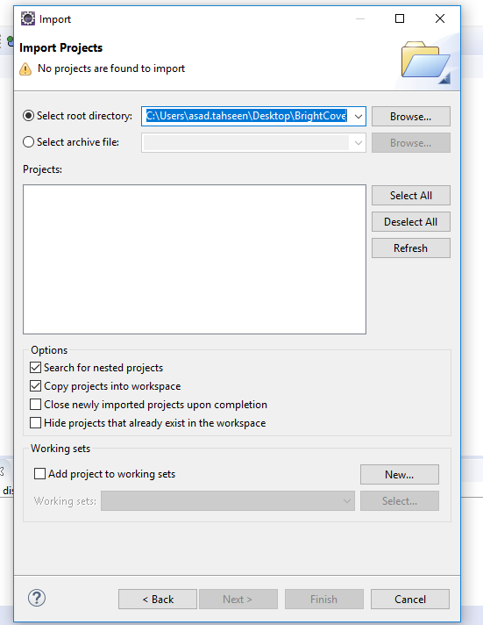

1. Upload cartridge to the sandbox
2. Select sandbox connection followed by **Properties**
3. Select Project Reference and check in the Brightcove Cartridges as it is going to be uploaded to the SFCC Instance.

## Setups in SFCC Business Manager:

1. To set up business manager go to

**Business Manager** followed by

**Select site** **>** **Manage Sites**

1. Select the **Site**, then select **Settings** tab. In the cartridge path add the following line

**Path:**

Note: Final screenshot for cartridge name provided in cartridge path will be here

1. Add cartridge to the cartridge path in

**Administration** followed by **Sites > Manage Sites >**

**Business Manager Settings**

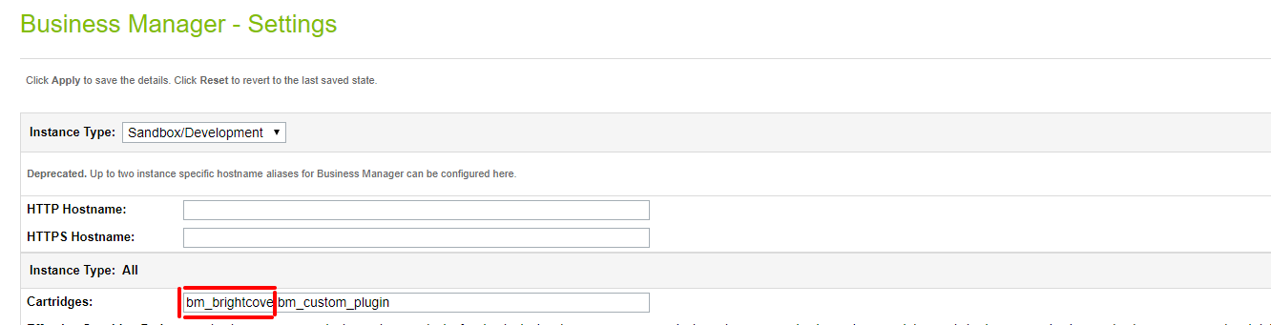

1. Once the path is successfully set

Select **Administration** followed by

**Site Development** -**> Import & Export**

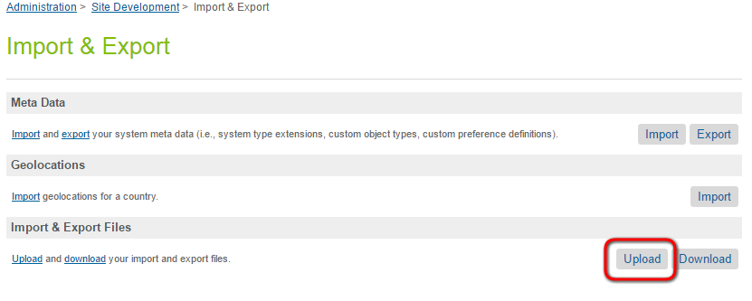

1. Upload **brightcove-objecttype-extensions.xml** from the metadata folder
2. Select **Import box** to follow steps to import **brightcove-objecttype-extensions.xml**

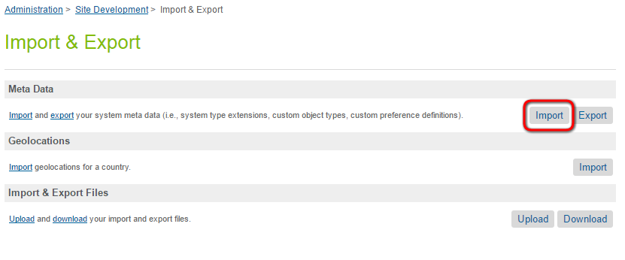

1. Once the path is imported

Select **Administration** followed by

**Operations > Import & Export**

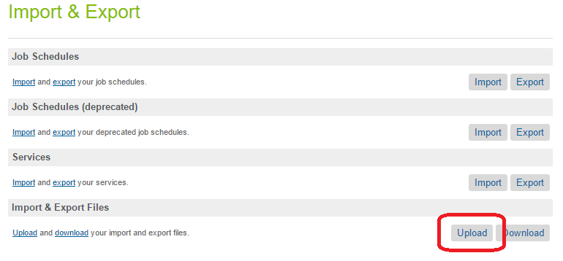

1. Upload **brightcove_services.xml** from the metadata folder.
2. Click on Import and follow the steps to import **brightcove_services.xml**

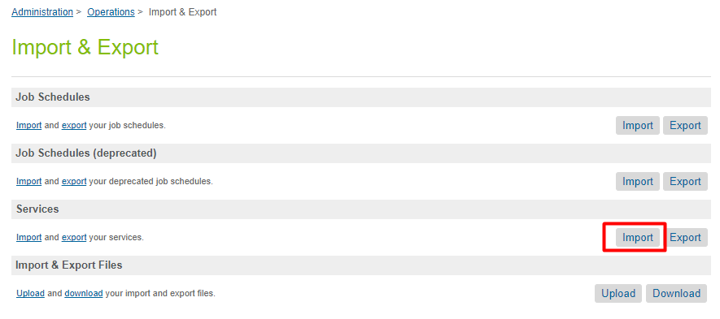

10. To check whether your business manager is all set

1. Go to **Administration > Organization > Roles & Permissions**
2. Select the specific user role **(Administrator)** followed by **Business Manager Modules > Select Context**
3. Select your site and click **Apply**
4. In the list of **Business Manager Module** **> Brightcove** and click to update permissions

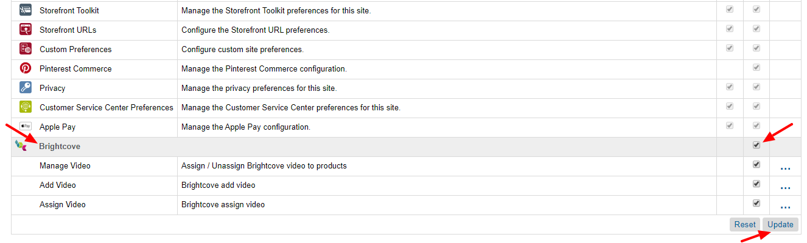

## Configure Custom Cartridge via Custom site preferences:

1. To configure custom cartridge via site preferences, select

**Business Manager** followed by

**Your Site > Site preferences**

1. Select **Custom Site Preferences > Brightcove**
2. Below is an example of how to complete the fields in the administration area

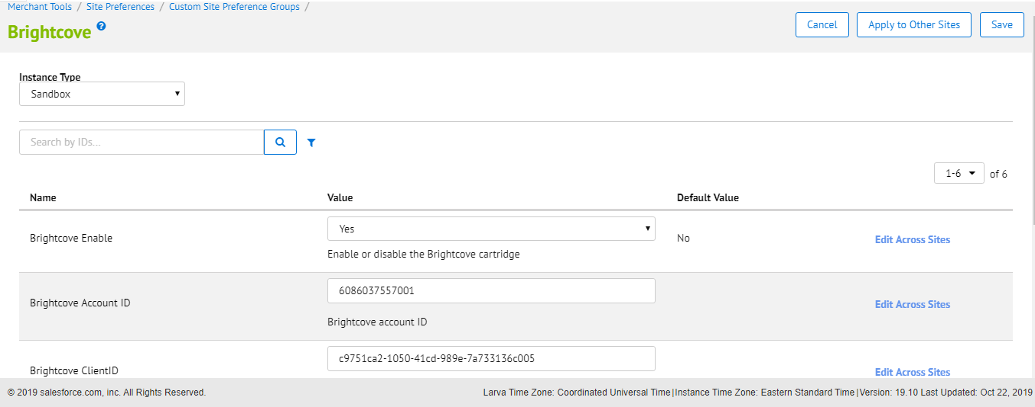

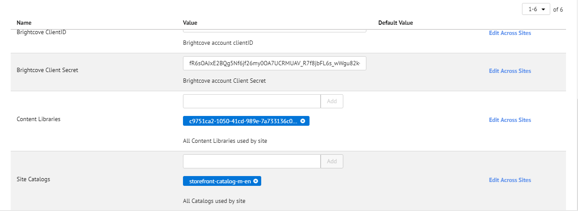

**Field description:**

* **Brightcove Enable** 🡪 turns on\off the Brightcove integration
* **Brightcove AccountID** 🡪Brightcove Account ID for Configuration
* **Brightcove ClientID** 🡪 Brightcove Account Client ID passed
* **Brightcove Client Secret Key** 🡪Brightcove client Secret Key for API calls
* **Content Libraries** 🡪 enter all Content Libraries used by the site
* **Site Catalogs** 🡪 enter all Catalogs used by the site